Invoice Query – South Korea
SOP Name | Version | Date | Author | L1 | L2 | L3 | L4
Invoice Query- Japan | 1 | 2026.04.03 | CWQ004/CMJ017 | Order To Cash | Billing & Invoicing | Apply Charge Transported by Maersk | Apply automated charges and Invoicing_Ocean (As-Is)
- HWS(Heavy Load Surcharge)
- WDF(Weight Discrepancy Fee)
- Late Payment Fee
- SPOT penalty
- CPU(CP3) / CPE(CP1)
- EHI(Equipment Handling Import)
- Import- Request web invoice request or official invoice ( not Arrive notice = DO INV) )

Standard Operating Procedure (SOP): Invoice Query Export Process HWS(Heavy Load Surcharge)
What is HWS?
In order to keep providing our global services, Maersk imposes a heavy load surcharge on containers whose verified gross mass (VGM) exceeds the specified weight
HWS Purpose
*Allow to maximize revenue
As we start to hit PSS/Freight ceiling levels in some regulated corridors, HWS will allow us to boost our top-line EBIT.
*Clear Narrative on the surcharge application
HWS allow use to make a clear narrative to the customers that the surcharge is applicable on the heavy cargoes.
*Allow to optimize available capacity
HWS is a gate control help us to steer the right cargoes on board.

HWS Application rule
1.Download HWS charge excel file form at booking journey
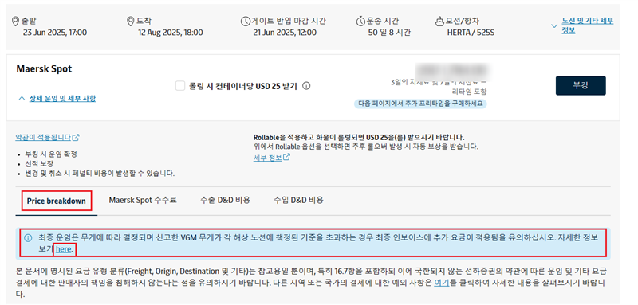

2.Check HWS excel file, it will show the scope and the last update date.
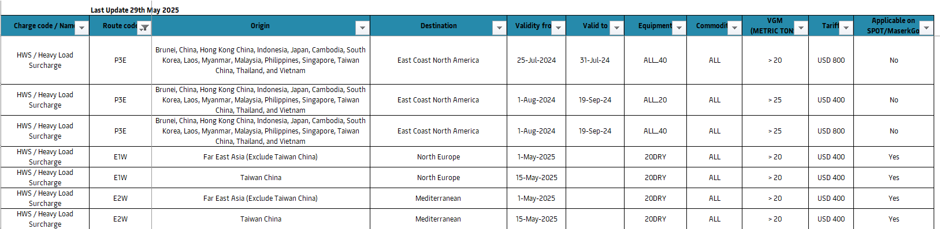

Q&A
Q:Customer ask whether the HWS will be charged? Or ask the HWS price?
A:
안녕하세요, 고객님,
머스크 수출 고객지원팀입니다.
스팟부킹시에는 해당 비용은 Breakdwon에 같이 표기되지 않습니다. 해당 비용은 최종 제출된 중량에 따라 추가되는 비용으로 부킹시점 입력된 중량을 반영하여 운임표기가 되지 않습니다.HWS 비용 부과 국가 및 비용은 해당 안내의 here 클릭시 파일 자동 다운로드 됩니다.
해당 파일 다운로드하여 HWS 비용 발생여부 및 요율 확인 부탁드립니다.
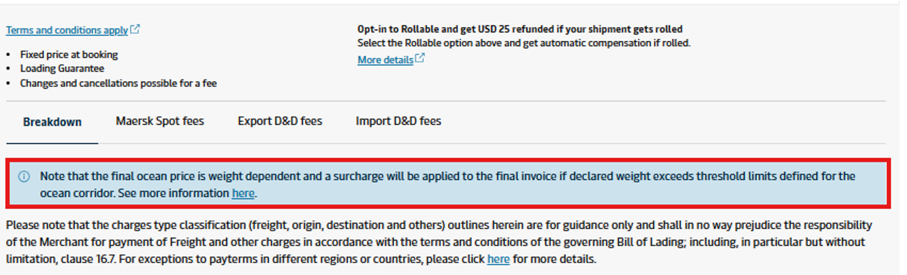
감사합니다.

Standard Operating Procedure (SOP): Invoice Query Export Process WDF(Weight Discrepancy Fee)

What is WDF?
- The difference (positive or negative) between the VGM weight and the weight declared in the shipping instructions is greater than 3000Kg.
- The VGM weight is greater than the maximum gross weight of the container, (as per CSC plate (Max Payload + Tare weight).
- The VGM weight is lesser than tare weight of the container.
- Charge : USD 300 per container, Any type and size

WDF Purpose
Ensure the safety compliance within shipping industry standards regarding weight declarations, to ensure safety of seafarer, operation crews and customer’s cargo.

How to check WDF charge
- dashboard link: WDF Charge Compliance - Power BI

Q&A
Q:Why did WDF apply?
A:
안녕하세요, 님,
머스크 수출팀 고객지원팀 XXX입니다.

아래와 해당 선적분의 WDF 산출 내역과 안내문 전달 드립니다.

[WDF(Weight Discrepancy Fee)관련 안내]
대상 : 2024년 10월 15일 출항 모선에 선적되는 컨테이너
• 적용 기준 **모두 최초 제출된 값에 해당
- 최초 SI 제출 값의 Weight와 VGM 값이 +- 3000KGS 차이가 나는 경우
- VGM값이 Container의 Tare값보다 작은 경우
- VGM값이 Max gross weight(May payload+tare weight)보다 큰 경우
- 부과 비용 : 컨테이너당 USD 300
• 유의 사항
컨테이너 분할 혹은 B/L SPLIT 진행분의 경우, 분할 중량 및 Split 중량에 Tare weight를 더하셔서 제출하지 마시고 반드시 컨테이너 1대분에 대한 중량+Tare weight를 확인하시어 VGM 제출 부탁드립니다.

감사합니다.

Q: When the customer requests an WDF reduction(waiver)
A:
안녕하세요, 님,
머스크 수출팀 고객지원팀 XXX입니다.

해당 비용은 시스템상 이슈가 아닌 경우, 별도 감면 처리가 어렵습니다. 해당 부분 참고하시어, 최초 SI 제출시 중량 값과 VGM값이 정확하게 입력될 수 있도록 협조 부탁드립니다.

3.2 When the customer claims a system error (Split Tp doc)
안녕하세요, 님,
머스크 수출팀 고객지원팀 XXX입니다.

해당 요청 관련하여 추가 확인 후 연락 드리겠습니다.

감사합니다.

Standard Operating Procedure (SOP): Invoice Query Export Process（Late Payment Fee）

What is Late Payment Fee?
LPF: The full name is the late payment fee. If the guest fails to complete the payment and settle the prepaid amount within ten days after the invoice is posted, a late payment fee will be charged. For credit Customers, since the fees are settled monthly, there will be no Late payment fee.

LPF Purpose

LPF is applied as a deterrent for late payment and control outstanding and it will ensure traders pay the freight and pick-up the B/Ls timely.

LPF Adjustment Notice
LPF Applying Rules
1/ LPF is applied for Non-credit clients. LPF is not applied for credit clients and advance payment customer.
2/ LPF is applied when shipper, consignee, or agent does not pay all prepaid charges in 7 days.
3/ LPF calculation is based on invoicing date.
4/ LPF calculation is based on calendar day.
5/Any holidays on week days will be excluded from due date calculation.
6/DCC will be sent to customers 2 working days prior to due date.
7/If there has been 3+days of delay on ATD after containers loaded on board, calculation will be started from ATD, not document date.

Surcharge Tariff
It is charged based on the invoice in the same way as the rate table and is applicable cumulatively.

Date | Fr ee Day | Rate
Day 1 – 7 | 7 | Free
Day 8 - 14 | 6 | USD 50
Day 15 - 21 | 6 | USD 50
*Repeat and accumulate the application according to the above method *
Q&A

Q: The causes and rules of LPF
A:
안녕하세요, 님,
머스크 수출팀 고객지원팀 입니다.

LPF는 인보이스 발행일로부터 7일이 경과한 후, 8일째 되는 날부터 부과되며, 주중 공휴일은 제외됩니다. 이에 대한 자세한 내용은 첨부된 안내문을 참고해 주시기 바랍니다.
또한, 인보이스 생성일 기준 7일 이내에 결제가 완료되어야 하니, 이 점 유념하시어 해당 비용을 기한 내에 입금해 주시 길 부탁드립니다.

감사합니다.

Q: When the customer requests an LPF reduction(waiver)
A:
안녕하세요, 님,
머스크 수출팀 고객지원팀 입니다.

LPF 는 고객님께 공유해드린 인보이스 금액의 지불이 지연됨에 따라 발생한 금액으로, 감액(Waive)이 어려운 점 양해 부탁드립니다.
또한, 당사 정책에 따라 인보이스 생성일 기준 7일이내에 결제가 완료되어야 하니, 이 점 참고하시여 해당 비용을 기한 내에 입금해 주시길 부탁드립니다.

감사합니다.

Q: If customer completes the payment within the deadline but submits the bank slip late, can the fee be waived
A:
안녕하세요, 님,
머스크 수출팀 고객지원팀 입니다.

LPF 기간내에 이체처리는 완료하셨으나 , 당사와의 입금처리만 지연 된 경우에는 재무팀(KR.PAYMENT.OCEAN@MAERSK.COM) 에 삭제 요청 접수 하실 수 있습니다. 이후 진행시 이체처리 후 즉시 입금처리하시어 진행 부탁드립니다.

감사합니다.

Q: Is the situation of public leave excluded?
A:
안녕하세요, 님,
머스크 수출팀 고객지원팀 입니다.

LPF는 인보이스 발행일로부터 7일이 경과한 후, 8일째 되는 날부터 부과되며, 주중 공휴일은 제외됩니다.
또한, 인보이스 생성일 기준 7일 이내에 결제가 완료되어야 하니, 이 점 유념하시어 해당 비용을 기한 내에 입금해 주시 길 부탁드립니다.

감사합니다.

Q: If the ATD is delayed by one or two days, will the due date of the delivery note be changed?
A:
안녕하세요, 님,
머스크 수출팀 고객지원팀 입니다.

3일 이후의 ATD 변경일 경우, LPF 의 게산 로직이 변경됩니다. 1~2틀의 지연은 인보이스 생성 날짜에 기준하여 LPF 부과 됩니다. 머스크의 인보이스 생성일 기준은 컨테이너가 해당 모선에 선적된 일을 기준으로 진행되고 있습니다.

감사합니다.

Standard Operating Procedure (SOP): Invoice Query Export Process（SPOT penalty）

What is the SPOT penalty?

The scope of customer and our commitments as well as the damages for non-compliance with such commitments shall be as set out in the table below:
Commitments | Customer’s commitment | Our commitment
Applicability of Two Way Commitment | The two-way commitments and the fees (if applicable) set out below applies from issuance of a Booking Confirmation.
Load as Booked | Customer commit to deliver the containerised Goods to us and provide to us any other required information and/or documents in a timely manner (including but not limited to shipping instructions) for any shipment before the applicable cut-off time(s). | Subject to customer complying with customer’s commitment, we shall load the Goods onboard:  (i) the original first leg ocean going vessel listed in the Booking Confirmation; or  (ii) an alternative vessel as long as that alternative vessel’s departure date is no earlier or later than three (3) days before or after the scheduled ETD as confirmed in the last sent version of the Booking Confirmation.
Cancellations, No-Shows and Booking Amendments
Cancellation | If customer cancel all or part of a shipment:  (a) After the Booking Confirmation has been issued; but  (b) Not less than seven (7) days before the scheduled estimated time of departure (“ETD”) of the original first leg ocean going vessel for that booking or part-booking,  Customer shall be liable to pay a cancellation fee on a per-container basis (“Cancellation Fee”).
No-show | If, customer:  (a) Fail to deliver and present to us part or all of a shipment on or before the cut-off date mentioned in the Booking Confirmation; or  (b) Provide notice of cancellation of that booking less than seven (7) days before the scheduled ETD,  Customer shall be liable to pay a no-show fee on a per-container basis (“No-Show Fee”).
Amendment | Any request by customer for booking amendment(s) will be subject to:  (i) Clause 2.6;  (ii) repricing, applying the current rates available on the platform at the time of processing the request; and  (iii) an amendment fee on a per-container basis (”Amendment Fee”), chargeable per container  Amendment(s) can only be made up until the ETD. After ETD it will not be permitted and if customer fail to deliver part or all Goods, customer will be liable for other consequences including No-show Fee.
Compensation Fee | We shall be liable to pay the Compensation fee, if both of the below conditions are met:  - We fail to load the containerised Goods on board the original first leg ocean going vessel listed in the Booking Confirmation (if such vessel’s departure is delayed or brought forward but the Goods are still loaded on board, then we shall not be deemed to have failed to load the Goods on board the vessel due to the fact that the actual departure is before or after the ETD in the Booking Confirmation); and  - For any reason within our control, we load the containerised Goods onto an alternative vessel that is more than three (3) days before the scheduled ETD as confirmed in the Booking confirmation.  The Compensation Fee is subject to any exclusions in these Spot Terms and shall only be payable if:  - Customer have paid in full for all services and all shipments in the Booking;  - Customer have complied with all Load as Booked commitments, as set out in these Terms;  - Customer have provided a written notice to us with claim for Compensation Fee, within 90 days from the date when the Goods were loaded on the ocean-going vessel responsible for the first leg of the voyage.  - An amount has been agreed and specified in the “Compensation Fee” column, of the “Fees table”, or Booking.  We shall only be liable for one Compensation Fee per container per spot booking.

- Advisory and useful link for Spot
https://www.maersk.com/local-information/asia-pacific/south-korea/expNKCort#
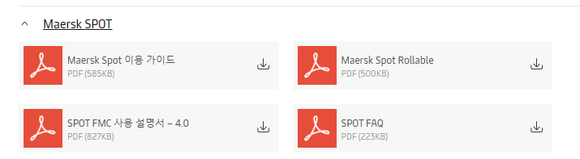

Spot related surcharges
Surcharge Name | New code | When this is applied
Spot Booking Cancellation Fee | SCL | for Booking cancellation 7 or more than 7 days before ETD.
Spot Booking Amendment Fee | SAE | for transport plan changes (By POR or POD or Schedule change)
Spot Booking No Show Fee | SNB | for Booking cancellation less than 7 days of ETD.
Spot Booking Cancellation Fee | SCR | Container reduction /container type size change 7 or more than 6 days ETD.
Spot Booking No Show Fee | SNS | Container reduction /container type size change less than 7 Days of ETD
Rollable Compensation | RBC | It only applies in case the booking is rolled by Carrier - due to circumstances within their control.

How to check SPOT penalty

1.Already booked a shipment
Shipment Notes=>User Defined
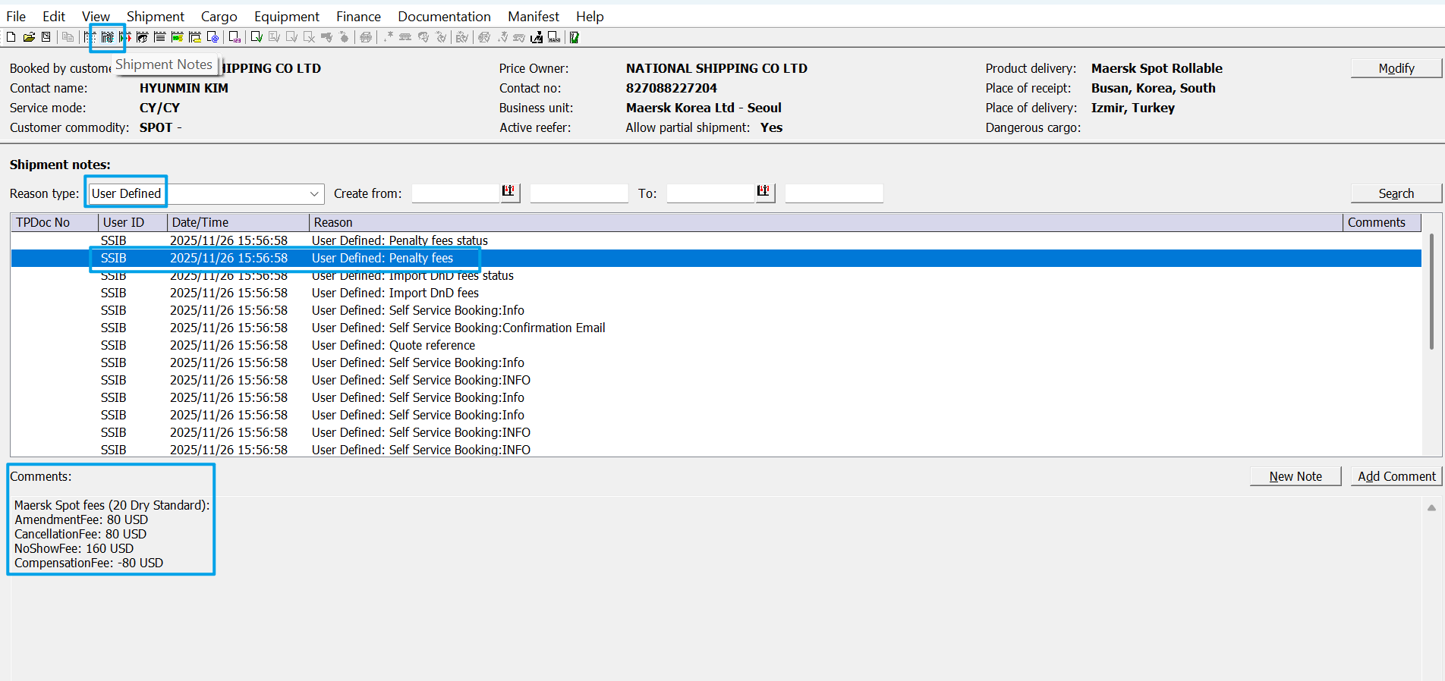

2.Before book a shipment

Terms for Spot Booking | Maersk Terms => 7. Commitments and Damages
=> Fees=>here

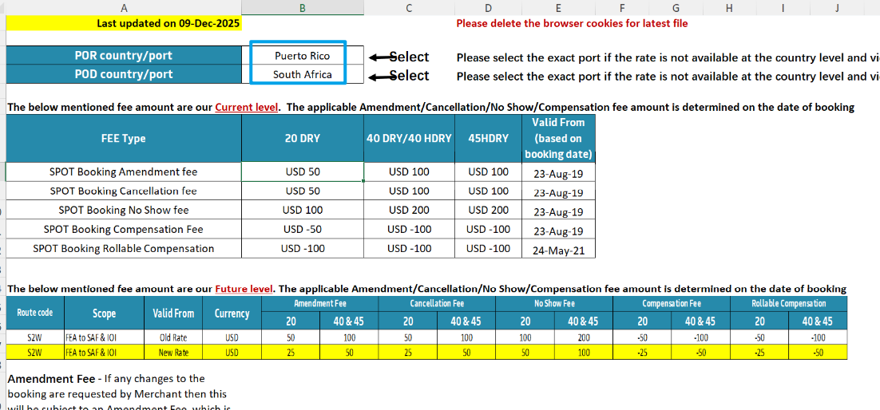

Q&A
Q:When customer ask why Amendment/cancellation has been charged
A:
안녕하세요, 님,
머스크 수출팀 고객지원팀 XXX입니다.

SPOT 부킹의 경우, 부킹 제출 이후 고객 사유로 부킹 정정이나 취소가 발생할 시 컨테이너당 페널티가 부과됩니다.
해당 건은 xx월 xx일 XXX 를 정정하신 것으로 확인되며, 관련하여 SPOT 가이드를 첨부해 드리니 참고해 주시기 바랍니다.

감사합니다.

Q:When customer request waiver request
A:
안녕하세요, 님,
머스크 수출팀 고객지원팀 XXX입니다.

SPOT 부킹의 경우, 부킹 제출 이후 고객님의 사유로 부킹 정정이나 취소가 발생할 경우, 컨테이너당 페널티가 부과됩니다. 부킹 진행 혹은 정정시 안내드린 내용을 참고해 주시길 바라며, 해당 비용은 면제되지 않음을 양해 부탁드립니다.

감사합니다.

Q: Rollable Compensation
A:
안녕하세요, 님,
머스크 수출팀 고객지원팀 XXX입니다.

Maersk spot rollable 은 Spot으로 부킹 시, 선사의 선복 이슈 등으로 인해 roll-over 발생된 경우 경우 별도의 보상비용이 적용되고 있습니다.
해당 보상 비용은 다른 선적분으로 상계처리 가능하시며, 해당 금액을 사용하실 경우, 재무팀(kr.payment.ocean@maersk.com )으로 사용요청 주시면 됩니다.

감사합니다.

Standard Operating Procedure (SOP): Invoice Query Korea Import Process CPU(CP3) / CPE(CP1)?

A Complete Step-by-Step Guide for New Users
What is the CPU(CP3) / CPE(CP1)?
CP1 = CPE= Container Protect Essential
CP3 = CPU = Container Protect Unlimited
Container Protect Essential : provides limited coverage for container damages and cleaning costs, across all commodities. If repairs exceed the coverage limit, only the additional amount is billed.
Container Protect Unlimited : provides unlimited coverage for container damage and cleaning costs, across all commodities.
Korea Tariff (*Metal/battery commodities, CPE will be updated to CPU)

Customer advisory regarding the launch of new Logistics Solution product – Container Protect :
Maersk are always care our customers, and that’s why we are continuously striving to simplify the way you do business with us. Container damages can happen at any stage of your supply chain, so we decided to launch a new product that provides hassle-free damage settlement process with no surprise costs (within the coverage limit). As from PCD (price calculation date) June 1st, Container Protect Essential will come into effect, and it will be applicable to all shipments imported into Korea as part of your destination charges replacing the existing Import Service (IMP) and Equipment Management Imports (EMI).

Package Introduction：
 | 40' | 20' | Coverage
Container Protect Essential (current IMP) Mandatory for all cargoes except Metal and Battery | KRW50,000/container | KRW35,000/container | Up to USD400 (or KRW480,000)
Container Protect Unlimited (current IMP+EMI) Mandatory for Metal and Battery  Optional for other commodities | KRW114,000/container | KRW99,000/container | Unlimited coverage

- The purpose of this charge is to compensate for the cost of cleaning, repair, and maintenance of containers in Korea. If the repair/cleaning fee exceeds the limit amount for Container Protect Essential, customers will be charged only the difference between the actual repair fee and the coverage limit.

[Example]
If the repair cost is USD450 and customer has already paid for Container Protect Essential, they will only be charged USD50; if customer has purchased Container Protect Unlimited, there will be no charge.
- SOC (Shippers' Owned Container) is not applicable.
- If you would like to upgrade your package to have unlimited coverage for container damage/cleaning fee, we will be offering Container Protect Add-On as optional purchase.
 | 40' | 20' | Coverage
Container Protect Add-on  Optional on top of  Container Protect Essential commodities | additional KRW64,000/container to Container Protect Essential | additional KRW64,000/container to Container Protect Essential | Unlimited coverage

Effective date: As from PCD (price calculation date) June 1st 2022
What You Need Before Starting
- Access to GCSS (Global Customer Service System)
- Email access to receive customer requests and check service view （Case Management）
- Basic computer skills
- Access to My Finance System

Invoice Availability
Invoice will be available through:
A. MyFinance on Maersk.com
Steps to access:
- Log in using prepaid invoice party Customer Code.
- Navigate to MyFinance.
- Enter your Shipment or Invoice Number.
- Select the relevant invoice.
B. Service View in Case Management
Steps to access:
- Click Service View in Case Management.
- Enter the shipment number.
- Click Pricing & Invoice tab.
- Click Invoice.
- Enter Customer Code → Click Get Invoice.
- Select the relevant invoice.
STEP-BY-STEP PROCESS Step
Step 1: Receive and Read the Customer Email
When a customer sends an email requesting an invoice:
1.Open the email from the customer
2.Read it carefully - look for
- What they're asking for (CPU/ CPE )
- Asking for What kind of charge is CPU/ CPE
- Asking for the CPU/ CPE charge is wrong.

Step 2:
- If customer Asking for What kind of charge is CPU/ CPE, reply to customer as below template and send an attach CA file.
안녕하세요. 머스크 고객경험관리팀 xxx 입니다.
문의하신 Container Protect 비용은 컨테이너 청결 유지 비용(Container cleaning) 및 장비 관리와 수리 비용이 포함되어 있는 도착지 청구 비용입니다.
문의하신 Container Protect 관련 안내문 전달 드립니다.

- If customer asking for the CPU/ CPE charge is wrong. reply to customer as below template and send an ISR to origin.
안녕하세요. 머스크 고객경험관리팀 xxx 입니다.
선적지에서 운임 계약한 내용으로, 해당 비용의 정확한 내용을 확인하기 위해서는 선적지와 확인이 필요합니다. 저희도 선적지 머스크와 확인하겠으나 , 빠른 확인을 위해서 선적지의 파트너에게 확인 요청 바랍니다.

Standard Operating Procedure (SOP): Invoice Query Korea Import Process EHI (Equipment Handling Import)

A Complete Step-by-Step Guide for New Users
What is the EHI (Equipment Handling Import)?
Surcharge Name Change from Marchant Haulage Import to Equipment Handling Import. ( MHI->EHI)
Please kindly be informed that, in term of material structure change, MHI/E(Marchant Haulage Import/Export) charge will be decommissioned by end of May and instead, replaced with EHI/E(Equipment Handling Import/Export) charge, effective from 1st of June, 2023.
Other than surcharge name change, rest would remain unchanged. All imports reefer containers to Republic of Korea: KRW40,000 per container.

Package Introduction：
All import reefer containers to Republic of Korea: KRW40,000 per container

Effective date: 2023-2-17
What You Need Before Starting
- Access to GCSS (Global Customer Service System)
- Email access to receive customer requests and check service view （Case Management）
- Basic computer skills
- Access to My Finance System

Invoice Availability
Invoice will be available through:
A. MyFinance on Maersk.com
Steps to access:
- Log in using prepaid invoice party Customer Code.
- Navigate to MyFinance.
- Enter your Shipment or Invoice Number.
- Select the relevant invoice.
B. Service View in Case Management
Steps to access:
- Click Service View in Case Management.
- Enter the shipment number.
- Click Pricing & Invoice tab.
- Click Invoice.
- Enter Customer Code → Click Get Invoice.
- Select the relevant invoice.
STEP-BY-STEP PROCESS Step
Step 1: Receive and Read the Customer Email
When a customer sends an email requesting an invoice:
1.Open the email from the customer
2.Read it carefully - look for
- What they're asking for (MHI->EHI )
- Asking for What kind of charge is MHI or EHI

Step 2:
If customer Asking for What kind of charge is MHI or EHI, reply to customer as below template and send an attach CA file.
안녕하세요. 머스크 고객경험관리팀 xxx 입니다.
냉동/냉장 컨테이너 반납 시, 컨테이너의 정상 작동 검사/확인을 위한 비용이며 관련 안내문 첨부합니다.
감사합니다.

Standard Operating Procedure (SOP): Invoice Query Korea IMPORT Process（EPS: Equipment Positioning Service - Import）
A Complete Step-by-Step Guide for New Users
What is the EPS/PED/SBF?
SBF -Standard Bunker Adjustment Factor Charge
PED / EPS -Equipment Positioning service

•As is : [SBF] - Standard Bunker Adjustment Factor
TO BE : [PED] / [EPS] -Equipment positioning Service- Import

Charge changing history LOG:
2021-12-01:
With series of simplification process on surcharge- we are regularly reviewing all the surcharges to see whether we can discontinue some of the surcharges and possibly merge with others- all to serve our customers in more simplified ways.
In this regard, we have plans to discontinue surcharge code ‘SBF (Standard Bunker adjustment Factor) and this will be replaced with ‘PED’ (Equipment positioning Service- Import) and also terminate PED charge for KRINC (Incheon) import. Please refer to the below for more details.

SBF replaced with PED – SBF will be simply replaced with code ‘PED’ for below corridors
  - Effective date: 1st of Jan, 2022 (based on PCD)
  - Affected corridors
    - Korea to Japan: USD 125/TEU
    - PRE to Korea: USD 260/TEU
    - PRN to Korea: USD 220/TEU iv. PRS to Korea: USD 150/TEU
v. Rest of countries (excluding Taiwan and Bangladesh): USD 150/TEU

PED termination – this will be terminated from below mentioned date.
  - Effective date: 1st of Jan, 2022 (Based on PCD)
  - Corridor: Import to KRINC, Korea C. Quantum: USD 50/TEU

2025-5-15:
In order to keep providing you with our global services, Maersk is regularly reviewing all surcharges to see whether we can discontinue some of the surcharges and possibly merge with others – all to serve our customers in more simplified ways.
After the brand unification of Sealand Asia into Maersk in 2023, this is a gentle reminder that we have discontinued ‘Standard Bunker Adjustment Factor’ (SBF) and this has been replaced with ‘Equipment Positioning Service – Import (PED) since 1st Jan 2022.
This is applicable to the following trades in the table below and this charge is to be paid at destination.

Charge Name | Charge Code | Corridors | 20’Dry  & 20’REEF | 40’Dry/40’Hdry/45’Dry & 40’REEF/HREF | Calculation
Equipment Positioning Service | PED | Korea, South to Japan | USD230 | USD460 | Per container
Equipment Positioning Service | PED | Mainland China East (PRE) | USD260 | USD520 | Per container
Equipment Positioning Service | PED | Mainland China North (PRN) | USD220 | USD440 | Per container
Equipment Positioning Service | PED | Mainland China South (PRS) & Hong Kong | USD150 | USD300 | Per container
Equipment Positioning Service | PED | All Intra-Asia Countries* (except  Mainland China) to Korea, South | USD150 | USD300 | Per container
*Intra-Asia Countries are China, Taiwan China, Hong Kong China, Malaysia, Singapore, Thailand, Vietnam, Myanmar, Cambodia, Indonesia, Philippines, Brunei, Timor-Leste, and Bangladesh.

What You Need Before Starting
- Access to GCSS (Global Customer Service System)
- Email access to receive customer requests and check service view （Case Management）
- Basic computer skills

STEP-BY-STEP PROCESS Step
Step 1: Receive and Read the Customer Email
When a customer sends an email requesting What kind of charge is (EPS/PED/SBF)
1.Open the email from the customer
2.Read it carefully - look for
* What they're asking for (If customer provide screenshot, need reading screenshot, If customer attached file, please open the file and check what’s the charges what customer is asking for)
* Their shipment details
* Any specific requirements

Step 2: Reply to customer what’s the charge of (EPS/PED/SBF)
Send this email template to customer with customer CA file. ( need attached in email._
안녕하세요. 머스크 고객경험관리팀 입니다.
해당 비용은 기존에 부과되던 standard bunker adjustment factor charge 항목이 EPS 로 명칭이 변경되었으며, 도착지인 한국에서 지불해야 하는 항목입니다. 관련 안내문 첨부합니다.
감사합니다.

Standard Operating Procedure (SOP): Request web invoice request or official invoice ( not Arrive notice = DO INV) )
A Complete Step-by-Step Guide for New Users
What is web invoice request ( formal web invoice) for KOREA IMPORT team?
Currently, the Korea Import Team provides the freight details on the Arrival Notice documents to our customers. Many clients are also using the Arrival Notice instead of the freight invoice to process their payments. However, some customers occasionally request a formal web invoice rather than the freight details listed on the Arrival Notice. Therefore, it is important to accurately determine whether the customer requires the Arrival Notice with freight details or a formal web invoice, so that the case can be handled appropriately. According to internal SOP, if the web invoice requestor is not the actual consignee, web invoices cannot be provided by us. In such cases, we guide customers to download the web invoice directly from the our website. However, if the web invoice requestor is the actual consignee, you should download the web invoice document and send it to the customer as an email attachment. Therefore, it is important to accurately determine who the requested party is

How to determine whether the customer requires a web invoice (formal web invoice)?
If you receive a request with the wording below in an customer’s email, it is most likely a web invoice request. In other words, requests such as asking for an invoice that separately displays KRW and foreign currency amounts, requesting an invoice in KRW only, requesting an invoice with combined KRW and foreign currency amounts, or requesting separate KRW and foreign currency invoices are all included within this SOP.
KRW 금액으로 정정해서 보내 주시기 바랍니다.
외화+원화 합산 인보이스 부탁 드립니다.
외화/원화 따로 인보이스 받을 수 있을까요?
분리 발행된 인보이스 발행 바랍니다.
원화 합산 인보이스 요청 드립니다.

What You Need Before Starting
- Access to GCSS (Global Customer Service System)
- Email access to receive customer requests and check service view （Case Management）
- Basic computer skills
- Access to My Finance System

Invoice Availability
Invoice will be available through:
A. MyFinance on Maersk.com
Steps to access:
- Log in using collect invoice party Customer Code.
- Navigate to MyFinance.
- Enter your Shipment or Invoice Number.
- Select the relevant invoice.
B. Service View in Case Management
Steps to access:
- Click Service View in Case Management.
- Enter the shipment number.
- Click Pricing & Invoice tab.
- Click Invoice.
- Enter Customer Code → Click Get Invoice.
- Select the relevant invoice.

STEP-BY-STEP PROCESS Step
Step 1: Receive and Read the Customer Email
When a customer sends an email request web invoice :
1.Open the email from the customer
2.Read it carefully - look for
- Web Invoice is Available for download for customer requested BL.
- Shipments destination country is South Korea.
- The Email sender company is same as shipment consignee or switched consignee or doc consignee.
- The collect payer code is Korea customer ( payer code start with ‘418’)
- No any other specific requirements
Step 2: After checking all above step (a-e) ,
- If all checking point is ‘YES’, Send this email template as an email attachment to customer
안녕하세요, 고객님,
머스크 수입부서 입니다.
요청하신 인보이스 서류를 본 메일로 첨부하여 전달 드리오니 확인 부탁드립니다.
감사합니다.
- If ‘NO’ for checking point ‘e’, Stop to reply to customer, it is not for this SOP.
- If ‘NO’ for checking point ‘a’, it need create web invoice by related team ( APAUBSO@maersk.com). it no need check next step, Please send email to related party to generate web invoice.
- If ‘NO’ for checking point ‘b’, it no need check next step, please stop checking and reply customer as below template.
안녕하세요, 고객님,
머스크 수입부서 입니다.
요청하신 비엘은 한국 수입으로 진행되는 비엘이 아닌것으로 확인 되오니 비엘번호 재확인 부탁드립니다.
감사합니다.

- If ‘NO’ for checking point ‘c’, it no need check next step, please stop checking and reply customer as below template.
안녕하세요, 고객님,
머스크 수입부서 입니다.

해당 인보이스는 머스크 웹상에 업로드 된것으로 확인됩니다.
내부 프로세스 상 현재 실화주에만 요청주신 웹 인보이스 전달이 가능한 점 양해 부탁 드리며, 핸들링 업체이신 경우, Master BL상 Consignee(실화주) 측으로 요청하시어 받아보실 수 있습니다.
A/N상에 DO비용 모두 표기되어 있는 바, 대행업체에서는 A/N상의 금액 참조하셔서 인보이스 대용으로 사용하시면 됩니다. USD의 경우 환율정보는 맨앞장에 나와있습니다.
그럼에도 불구하고 웹 인보이스가 필요하신 경우에는 머스크 웹 사이트(www.maersk.com)에 가입 후 로그인하셔서 직접 다운로드 받으시길 바랍니다.
웹 로그인 후 관리> MY FINANCE에 들어가서 I'M AN AGENT 누르고 BL번호 입력하시면 운임 인보이스 조회 가능 합니다. (다만 USD 금액 인보이스의 경우 제약이 있어 제3자 조회 안됨)
감사합니다.

- If ‘NO’ for checking point ‘d’, it no need check next step, please stop checking and reply customer as below template.
안녕하세요, 고객님,
머스크 수입부서 입니다.
요청주신 인보이스 payer code 는 타국가 코드로 확인되어 해당 국가의 고객 지원팀으로 직접 요청 부탁드립니다.
감사합니다.

Invoice query

Direction Korea Import

SOP Name | Version | Date | Author | L1 | L2 | L3 | L4
Invoice query- South Korea | 1 | 202607.29 | HJH037 | Order To Cash | Billing & Invoicing | Apply Charge Transported by Maersk | Apply automated charges and Invoicing_Ocean (As-Is)

- Charge amendment checking
Key word: 프리페이드 정정 여부 확인/ Prepaid 정정 여부 확인

Received request via CM as below
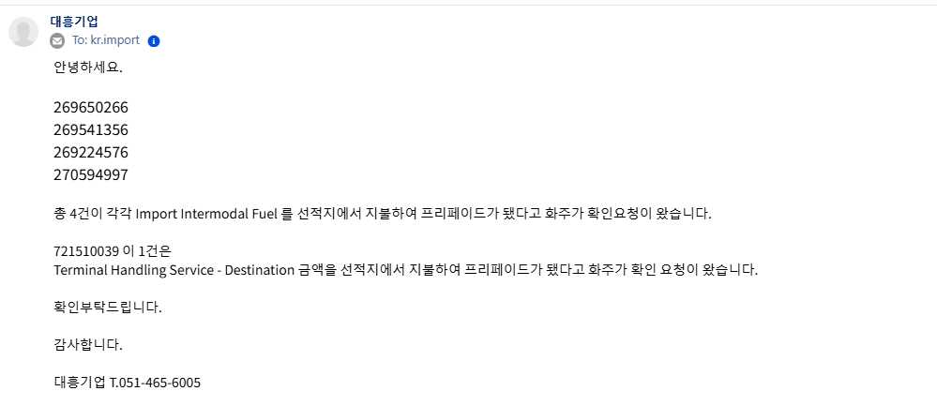
open bill in gcss and check ctrl+G price page, Check if the charge mentioned by the customer has been changed to prepaid.
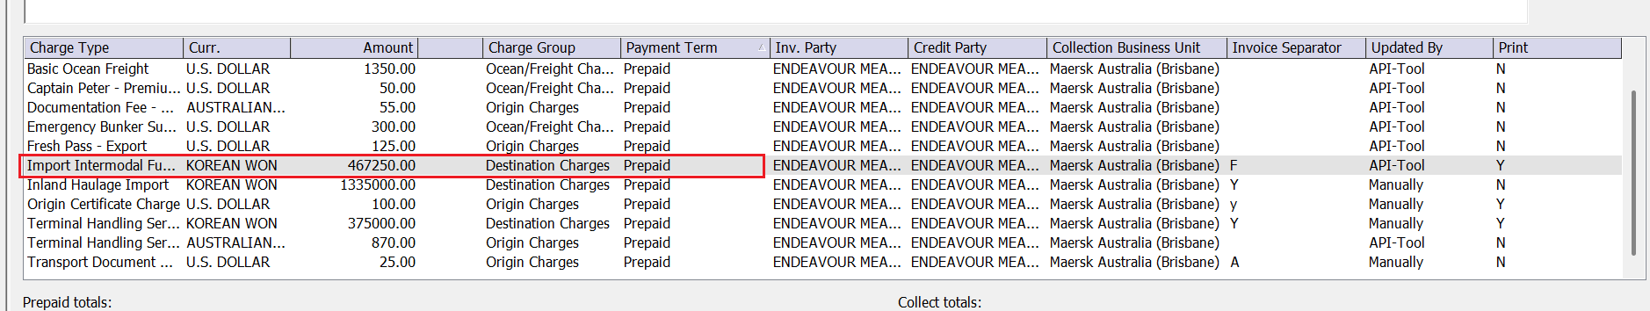

If charge already changed to prepaid, please reply customer below template:

안녕하세요 머스크 수입팀입니다.

문의하신 비용 시스템상 prepaid로 등록되어 있으니 참고부탁드립니다.

감사합니다.

If charge still not change to prepaid, please reply customer below template:

안녕하세요 머스크 수입팀입니다.

문의하신 비용 시스템상 collect로 등록되어 있으니 참고부탁드립니다. 비용 정정여부 선적지 업무팀과 재확인부탁드립니다.

감사합니다.

- EPS-Equipment Positioning service / Container Protect Essential / Container Protect Unlimited 문의(query)

- EPS-Equipment Positioning service, please reply below template and attach file to csutomer

안녕하세요 머스크 수입팀입니다.

해당 비용은 기존에 부과되던 standard bunker adjustment factor charge 항목이 EPS 로 명칭이 변경되었으며, 도착지인 한국에서 지불해야 하는 항목입니다. 관련 안내문 첨부 드립니다.

감사합니다.
FILE:

- Container Protect Essential / Container Protect Unlimited, please reply below template and attach file to csutomer
안녕하세요 머스크 수입팀입니다.

문의하신 Container Protect 비용은 컨테이너 청결 유지 비용(Container cleaning) 및 장비 관리와 수리 비용이 포함되어 있는 도착지 청구 비용입니다.

문의하신 Container Protect 관련 안내문 첨부 드립니다.

감사합니다.
File:

- Invoice request
Key word: INV 업로드/ 인보이스 요청/웹 인보이스 요청/web 인보이스(invoice)요청/

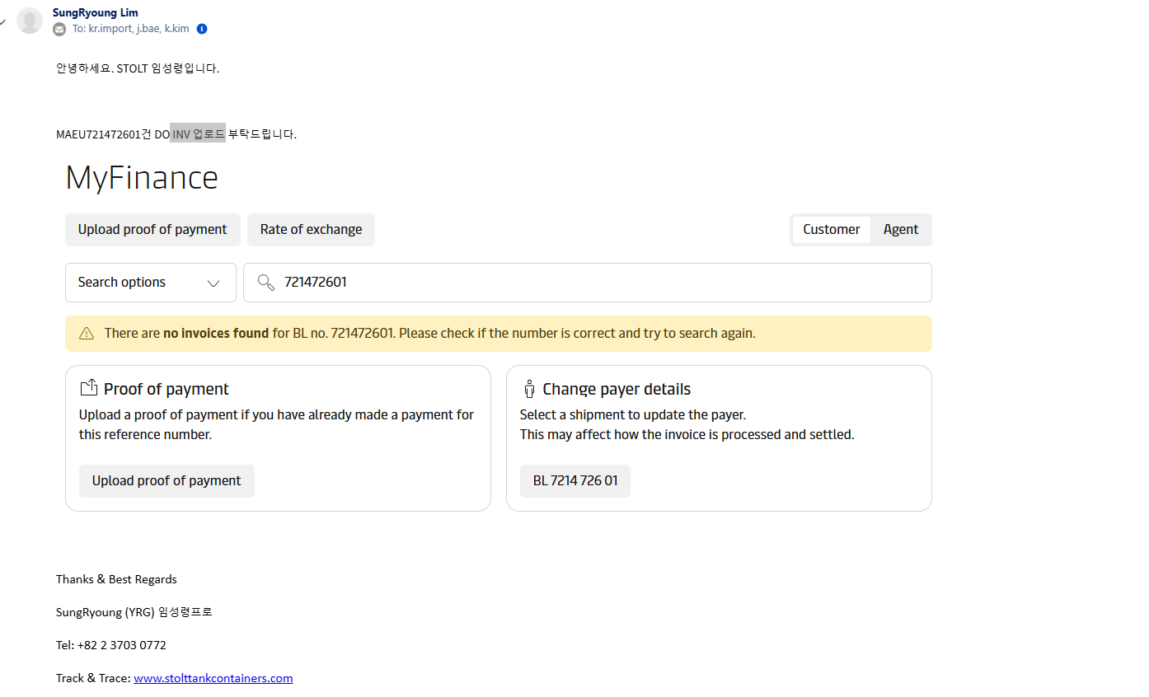
Step 1: open bill in gcss and check SCIR status.

Open :need manual review by user

Step 2: Closed, and check requestor if actual CNEE
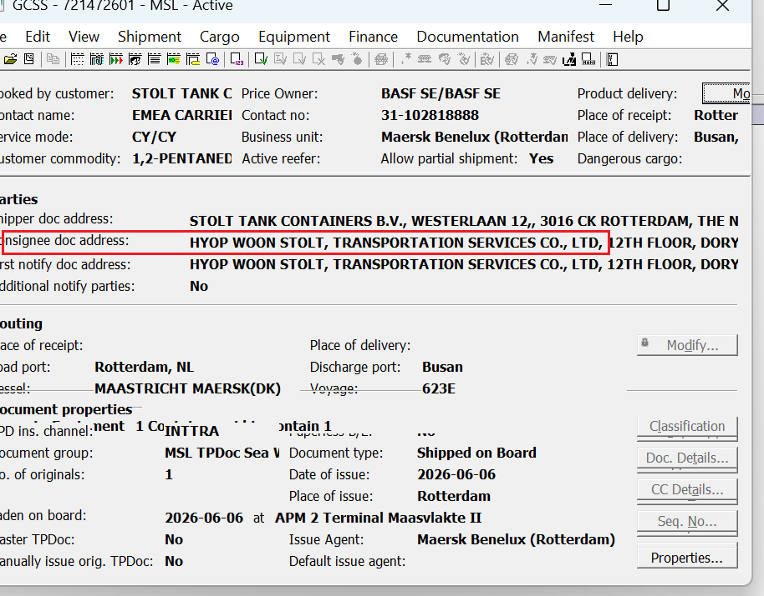
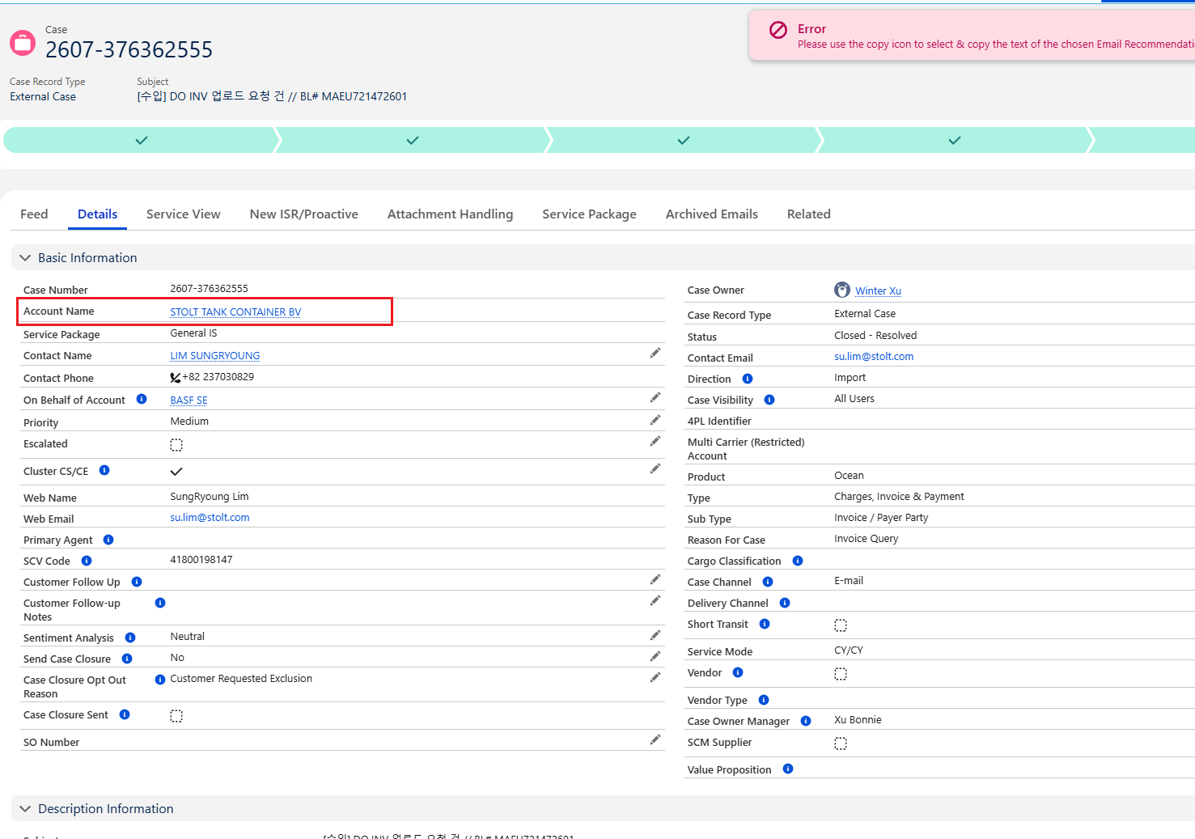

Not Actual CNEE, please reply below template:

안녕하세요 머스크 수입팀입니다.

내부 프로세스 상 현재 실화주에만 요청주신 웹 인보이스(원화 인보이스) 전달이 가능한 점 양해 부탁 드립니다.
A/N상에 DO비용 모두 표기되어 있는 바, 대행업체에서는 A/N상의 금액 참조하셔서 인보이스 대용으로 사용하시면 됩니다. USD의 경우 환율정보는 맨앞장에 나와있습니다.
그럼에도 불구하고 웹 인보이스가 필요하신 경우에는 머스크 웹 사이트(www.maersk.com)에 가입 후 로그인하셔서 직접 다운로드 받으시길 바랍니다.
웹 로그인 후 관리> MY FINANCE에 들어가서 I'M AN AGENT 누르고 BL번호 입력하시면 운임 인보이스 조회 가능 합니다. (다만 USD 금액 인보이스의 경우 제약이 있어 제3자 조회 안됨)

감사합니다.

Actual CNEE, need download invoice from web site and attach invoice file to customer with below template:

안녕하세요 머스크 수입팀입니다.

요청하신 인보이스 첨부드리오니 참고부탁드립니다.

감사합니다.

- All prepaid
open bill in gcss and check ctrl+G price page, check all charge updated as prepaid

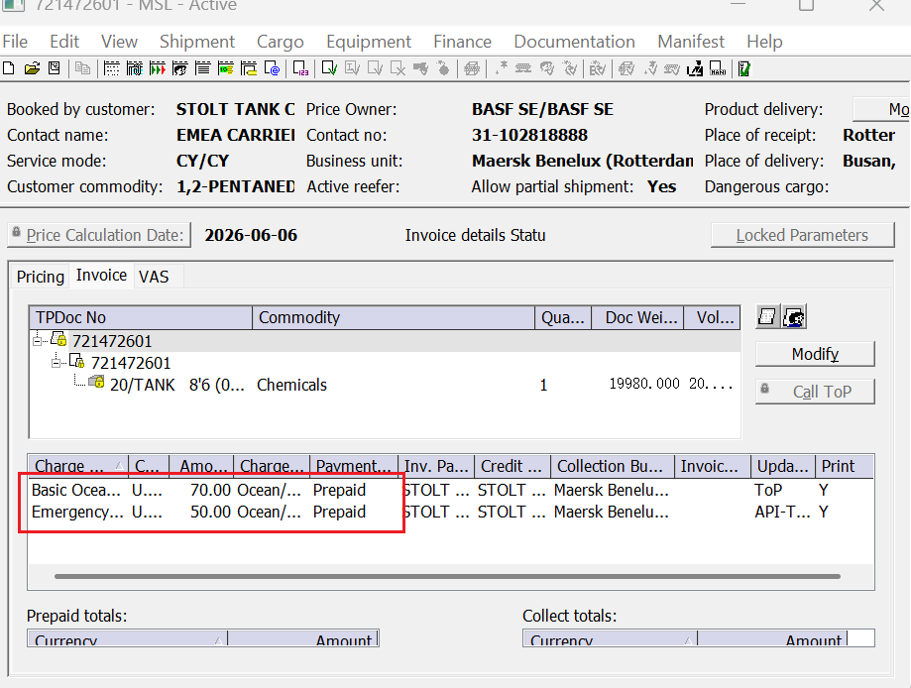

All charge prepaid, please reply to customer as below:

안녕하세요 머스크 수입팀입니다.

해당건은 ALL PREPAID 건으로 확인 되며 도착지에서 진행하실 운임 인보이스는 없습니다. 참고 바랍니다

감사합니다.

